template FOR paper/poster preparation

Obligatory structure of the paper:

Abstract

Keywords

Introduction

Main text (containing the methodological bases, experimental part, results and its discussion)

Conclusion

(Acknowledgements)

References

Text editor: MS WORD, the paper must be sent in docx format.
Page size: A4

Font: 10 pt Arial
Spacing: 1.2
Margin of the page: 20 mm from all sides

Please use the specific header in written paper. The maximum length of the paper is 6 pages.

Please use a predefined styles for writing the paper - click on the style.

TITLE OF PAPER (11 pt, bold, center, gaps 0 before, 6 after, spacing 1.2)
Authors (Name SURNAME) (11 pt, center, gaps 12 and 12, spacing 1.2)
e.g. ¹Jan NOVÁK, ²John ALTMAN
Name and address of the institution, e-mail address as hyperlink
(10 pt, italics, center, gaps 3 and 0, spacing 1.2), e.g.:
¹VSB - Technical University of Ostrava, Ostrava, Czech Republic, EU, novak@vsb.cz
²University of Strathclyde, Faculty of Physics, Glasgow, Scotland, United Kingdom, EU, alt@strathclyde.com

“Do not delete this field. It is for internal use of the organizer.”

Abstract (title - 10 pt, bold, gaps 24 and 0)

(Text - 10 pt, gaps 6 and 0). Text of abstract should have extent to 250 words. Any equations, references tables or figures are not allowed. Abstract should briefly present the topic, state the scope of the experiments, indicate significant data, and point out major findings and conclusions.

Keywords: (title - 10 pt, bold, gaps 6 and 0, text - max 5 keywords, 10 pt, gaps 6 and 0, the first keyword
has first letter large, there is no punctuation at the end), e.g.:
Keywords: Metallurgy, steel, properties, applications, testing methods

chapter TITLES (10 pt, bold, gaps 18 and 0)

Use chapter titles for a clear structuring and an easy understanding of the text. The paper should be divided into chapter (and subchapter, if necessary - for example 1.1., 1.2. etc).
  - Subchapter title (10 pt, bold, gaps 12 and 0)

Introduction

The introduction should provide a clear statement of the study, the relevant literature on the study subject and the proposed approach or solution.

figures, equations, tables

It is recommended to put tables and figures within the text. Each table or figure should be titled and captioned. The title of the table should be written above the table to the left (10 pt, title - bold, text - real) and the title of the figure should be written under the figure to center (10 pt, title - bold, text - real). Title of the figures or tables are always composed of a bold consecutively numbered title with first letter large and the description (Examples are below). Title of the figures or tables starts with capital letter and does not end with dot (unless it is a multi-sentence title). Please do not use abbreviations (Fig. 1 - wrong, Figure 1 - correctly; Tab. 1 - wrong, Table 1 - correctly).

Figures are other illustrations such as graphs, charts, maps, drawings, photographs etc. Export charts or graphs as image file (.JPG, .PNG). Graphs must contain all of required particulars (description of axes, units in round brackets, etc. - see example - Figure 1). The figures should be original or quality scanned. We will not accept bad photocopy. Descriptions of the figures should be clear and legible. The figures and graphs should be placed within the text, not collected at the end of the document.

If a figure or table is reproduced from another source, it is necessary to use the citation of the source by number in square brackets, e.g. “Title of the figure [1]”. If the source is own, it is possible to use a label “[own study]” or do not use the citation information. If the citation information is missing figures and tables are considered as the own study. All the sources must have a full bibliographic entry in your References.

All tables and figures must be mentioned in the text. Refer to them in the text by their number with bold letters with first letter large - e.g. “Structure of production is shown in Figure 1” or “The structure of production was analyzed in detail (Figure 1)”; “Table 1 is dedicated to the electron microprobe...”. Please do not use cross-reference links for figures, tables, or references.

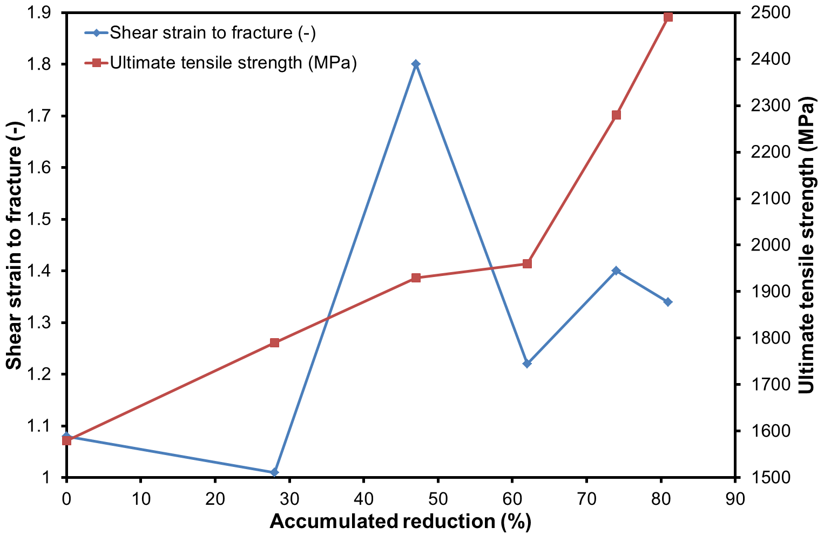

Figure 1 Title of the figure [x] (10 pt, gaps 6 and 12)

The position of the figures (in the figure position “Tab”) should be selected as the "In the text", gaps 12 and 0, centered. The position of the table is on the left-hand side. Next paragraph after the table or figure has gaps 12 and 0.

Example of the table:

Table 1 Electron microprobe analyses of sphalerite grains in the Kidd Creek ‘C’ concentrate
(font size of title: 10 pt, gaps 12 and 2; font size of the text: 9 pt, gaps 6 and 0, single spacing)
Element | Average  (wt%) | Range  (wt%)
Fe | 5.82 | 3.54 - 6.95
Cd | 0.30 | 0.12 - 0.42
S | 33.31 | 33.6 - 33.5

Tables are numerical values or text displayed in rows and columns. Column names are bold and centered. The location of the text in rows depends on the content of the table. Units of quantities are in round brackets. Please submit tables as editable text and not as images.

In numbers please use a decimal dot as decimal separator. English uses the comma to separate thousands and millions, f.e.:

1,000 = one thousand

1,000,563 = one million and five hundred and sixty three

1,000.563 = one thousand point five six three

1.25E+06 = 1,250,000

1.25E-06 = 0.00000125

Equations must be created in Equation Editor for Word (Microsoft Equation 3.0), written in the separate line on the left side and numbered sequentially throughout the text, i.e. (1), (2), (3) on the right-hand side. When referring to an equation in the text, always put the equation number in round brackets - e.g. „as in equation (2)“ and always spell out the word „equation“ in full, do not use abbreviations such as „eqn.“ or „eq.“.

Mathematical parameters should be written in italics, (not only in the equation itself but everywhere in the paper), but not units, numbers and mathematical functions like function names (sin, cos, log, ..), exact infinitesimal increments (dx, dy, …), descriptive text. If the term in question is a variable, then it should be italicized. All other terms should not be italicized. E.g.: sinx; logx = incorrect. sin x; log x = correct.

Decimal fractions should always be preceded by a zero: for example 0.123 not .123 (note, do not use commas, use the decimal point). All new symbols must be listed and defined immediately after each equation. Units of quantities are in round brackets.

(1)

where:

σ_{h} - the stress (MPa)

F_{k} - the forging force (N)

l_{z} - the length of action (mm)

b_{s} - the mean width of the elongated bar (mm)

Symbols for derived units formed by multiplication are joined with a half-height dot (⋅) or a non-breaking space; e.g., N⋅m or N m. Symbols are mathematical entities, not abbreviations, and as such do not have an appended period/full stop (.), unless the rules of grammar demand one for another reason, such as denoting the end of a sentence. Symbols for derived units formed by division are joined with a solidus (/), or given as a negative exponent. E.g., the "metre per second" can be written m/s, m s⁻¹, m⋅s⁻¹, or m/s. Only one solidus should be used; e.g., kg/(m⋅s²) and kg⋅m⁻¹⋅s⁻² are acceptable, but kg/m/s² is ambiguous and unacceptable. Symbols of units do not have a plural form; e.g., 25 kg, not 25 kgs. The number and its unit should be followed on the same line. Any line-break inside a number, inside a compound unit, or between number and unit should be avoided.

We ask you to keep writing repeating units and captions by these examples:

700 MPa; 100 g; 900 °C; 1040 K; 0.5 %; 1.5 h; W = 2000 mm; l_{d}/h₀ > 3; v = 600 m⋅s⁻¹ (mathematical dot in the middle row, insert not using the equation, but as a symbol); 5.2 x 10⁻⁵ W/(m⋅K); wt% or at.% - mandatory information for alloy composition in text, tables and figures.

Indicate sample dimensions as “0.1 cm × 0.2 cm,” not “0.1 × 0.2 cm².” The abbreviation for “seconds” is “s,” not “sec.” Do not mix complete spellings and abbreviations of units: use “Wb/m²” or “webers per square meter,” not “webers/m²”.

Note: A ton is unit of measurement being 2,000 pounds. A tonne is a metric ton, which is 1,000 kilograms.

INSTRUCTIONS FOR Bullets and numbering:

10 pt, gaps 6 and 0; do not add space between paragraphs of the same style (the first bullet has gaps 6 and 0 and the following bullets 0 and 0). It is only for bullets and numbering, not for regular text,

obligatory typographical symbol is Bullet point “•”,

use only numeric numbering - 1., 1.1., 1.1.1., etc. (not text numbering A., B.…),

hanging indent is 1 cm.

conclusion

The paper must contain conclusion. The conclusion should summarize the findings and explain the implications of the paper. Conclusion contains no new data or findings.

ACKNOWLEDGEMENTS

This section includes acknowledgment of people, grant details, funds, etc. Size font is 10 pt, italics, gaps 6 and 0, bold, center align.

references

The font size is 9 pt, gaps 3 and 0, right align. References should be listed together at the end of the paper, footnotes should not to be used for this purpose.

Within the text, references should be cited in numerical order according to their order of appearance. The number of cited references should be written in square brackets placed immediately after the text and continuously. In the case of two citations, the numbers should be separated by a comma [1,2]. In the case of more than two references, the numbers should be separated by a dash [5-7].

Data should be written in the language of the cited document. A recerence that is not written in Latin script should be transliterated (e.g. Cyrillic) or transcript (e.g. Chinese characters).

Range of auto citations in references should be max. 20 % including co-authors.

Range of citations on previous conferences METAL should be max. 20 %.

Examples of citing common types documents:

Examples are shown for: [1] - a book, [2] - a book chapter, [3] - a journal article, [4] - an e-source, [5] - a conference paper:
- MATTHEWS, J.R., MATTHEWS, W.R. Successful Scientific Writing: A Step-by-Step Guide for the Biological and Medical Sciences. Cambridge: Cambridge University Press, 2008.
- GODWIN, P. Library 2.0: a retrospective. In: GODWIN, P., PARKER J., eds. Information literacy beyond library 2.0. London: Facet, 2012, pp. 3-18.
- FATEHI, F., GRAY, L.C., WOOTTON, R. How to improve your PubMed/MEDLINE searches: 3. advanced searching, MeSH and My NCBI. Journal of Telemedicine and Telecare. 2014, vol. 20, no. 2, pp. 102-112.
- GLASGOW CALEDONIAN UNIVERSITY LIBRARY. Harvard British Standard: Referencing Guide [online]. [viewed 2016-02-23]. Available from: http://www.gcu.ac.uk/library/media/gcalwebv2/library/content/pdffiles/
Harvard%20Referencing%20Full%20Guide.pdf.
- MUNTIN, A., ZINYAGIN, A. FEM modeling and experimental research of through-thickness strain distribution during hot plate rolling. In METAL 2014: 23rd International Conference on Metallurgy and Materials. Ostrava: TANGER, 2014, pp. 377-382.

List of errors that authors make often:

Scientific goal and contribution of the paper is not clearly defined in the introduction of the paper,

absence of citations of the tables and figures in the text with relevant commentary,

highly technical terms or phraseology are not explained and defined,

absence of the conclusion,

lack of sufficient number of citations to the current foreign literature, especially journals,

missing bibliographic references in the text,

wrong format of cited references,

please note the abbreviation “i.e.,” means “that is,” and the abbreviation “e.g.,” means “for example” (these abbreviations are not italicized).

